Ellie

The living building

Emotion expression trough lights

Thijmen Brand (480490)

# Version history

|  |  |  |  |
| --- | --- | --- | --- |
| Date | Author | Comment | Version |
| 05-09-2022 | Brand T. |  | V1.0 |
| 14-09-2022 | Dijk M. | Update | V1.1 |

Table of Contents

Version history 2

Project scope 4

Introduction 5

Chapters 6

Final words 7

# Introduction

A part of the Ellie project is a living light. This light has emotions based on interaction with its surroundings like touch and sound. These emotions then are expressed through coloured led light. This document is written to document the development and research process of expressing emotions with lights.

# Emotions and colours

Different emotions are associated with different colours. And different colours evoke different emotions. A lot of lecture already exists on this topic. But not only the wavelength of a colour is important, also the brightness of the colour is form influence. Brightness is often associated with positive emotions and events and darkness with negative emotions and events[1]. The findings of this study map seamlessly to the finding of another study[2] which states that less bright colours like red, black and grey are often associated with negative emotions and more bright colours like yellow and white are often associated with positive emotions.

In the first version of our emotion expressing light the scope is to express four different emotions; Anger, Joy, Sadness and neutral.

With anger most literature states that red is the strongest colour to express anger. With two studies[3] conducted where people had to link the word anger to any colour, 76% of people said red, but also when people had to give word give a colour most people said anger.

[4]Joy is proven to mostly is associated with the colour yellow. However, not all people see yellow as a colour associated with joy. This degree of joy associated with yellow has to do with the environment a person lives in. When people live in rainier and colder climates further away from the equator, people tend to associate yellow with joy the most., But with warmer and sunnier climates people are less affected by this colour in term of joy.

[5]Blue can be calming and peaceful, but especially the darker shades of blue can give off a feeling of coldness. That’s why it also associates with sadness. A cold feeling of sadness.

[6]Lastly we have a neutral emotion, the most neutral colour for this is green. It represents balance and harmony and is associated with nature.

# Movement and emotions

Expressing emotions with light isn’t just emitting lights. Emotions also bring a feeling and movement with it. For example, sad people are low, the body is compact so they are little and slow. Every emotion has such characteristic movements.

In a research that was done to investigate emotion recognition from movement they concluded that[7] [8]:

Happiness makes people Rhythmic, Jumpy, Free and light and up and rise. People move a lot up and down, left to right.

Signs of sad movements are passive weight, so a person a person feels heavy and moves slow, the head is tilted downwards.

Angry emotions tend to be direct, sudden and strong. The movements are unpredictable and advance quick.

But these characteristics of movement with emotions aren’t directly applicable to light. We cant make a light move fast or make it jump. Or not with a single light. So in the next chapter I will explain how we can apply this behaviour and movement to an actual light.

# Applying emotions to light

That movement people make when they are feeling emotions or expressing emotions I discussed earlier is not ready to map onto a light. An average light can’t grow and shrink or jump. That why I first have to translate that complex movement to something that a light can express. I have done this by translating the movements to waves. For example, the happy emotion where someone is moving a lot all over the place, that can be some random wave where the brightness of the light changes. Or when I want to express angry in a light I can have a very spiky and abrupt wave that simulates the unpredictable and quick advancements.



Figure 2: Neutral light patern

Figure 1: Happy light patern



Figure 3: Angry light patern

Figure 4: Sad light patern

Besides changing brightness to express movement, I can do something more. There are many sorts of lights, and the light I have talked about in my document always was a single led light which could change colours and brightness. But I can also choose to use a neo pixel led ring. This is a ring with 16 led lights which all are individual operatable. With those extra options I can move left, right, up and down. So with this a whole extra dimension of expression becomes available to me. With this I can simulate a hanging head with only turning on the bottom leds. Or I can shake a head by turning the left and right lights around and around.

# Concrete implementation

If we apply and combine all the things I have discussed in this paper we can create a light that can express emotions.

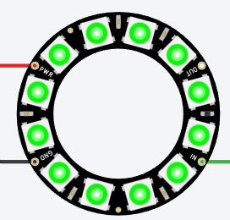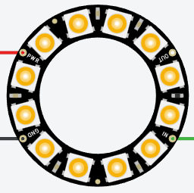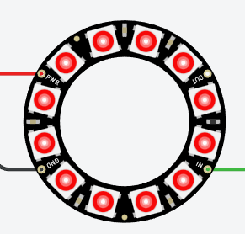So we take that neo pixel led ring to be able to make more complex emotions. Then we have to apply colours to express those emotions. So when it is angry the lights will display bright red, when sad it will be blue, with joy the lights are yellow and in a neutral state the lights are green.

Figure : Neutral colour

Figure : Sadness colour

Figure : Happiness colour

Figure : Anger colour

After this we can start applying the movement to the lights. This was done with the different kinds of graphs I showed earlier. But how can we get such a graph into our code and it would be nice if it was random each time. Well a graph is noting more then a bunch of points on a y and x axis with a line drawn in between them.

So we can generate the points. For example for the angry graph, which goes all over the place, We can generate a lots of random points between 0 and 255 (this is the brightness range of the neo pixel) we can simulate this shocking and abrupt motion.

And if we generate a few points between a more narrow range, lets say 150 and 255 we can simulate the neutral pattern with few motion.

So we can play with the amount of points and the values of the points to create a all sorts of different patterns and thus emotions.

The code for this looks as follows: We just have a method which fills an array with random number between the given min and max values. That’s all what is to it.

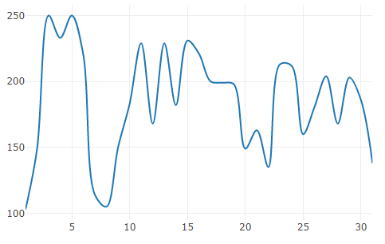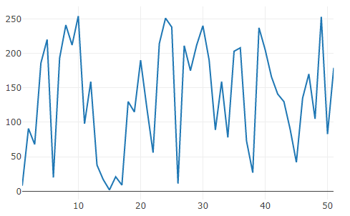So calling this method with different parameters we can get different results as you can see

Figure 8: Graph with 30 points and boundaries between 100 and 255

Figure 6: Graph with 50 points and boundaries between 0 and 255

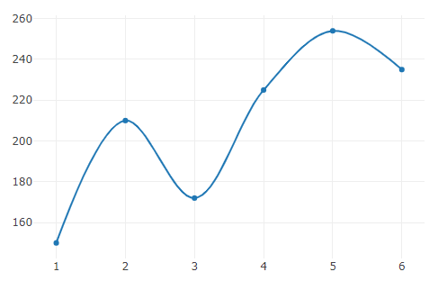

Figure 7: Graph with 5 points and boundaries between 150 and 255

Lastly we can play around with which lights are turned on or off. Ass mentioned earlier we can make it jump by toggling the upper and lower half of the ring around and around. Or make the head hang by slowly toggling lights more to the bottom.

if we combine these three things we have an lamp that express its emotions quite well with a few different ways.

# Final words

In this document I have looked to how I can translate emotions to lights. First I have looked at which colours are associated with the different emotions I want to use in the final project. Out of this research came anger mostly is associated with red, joy with yellow, sadness with blue and neutral can be best expressed by the colour green. Because these colours are mostly associated with the chosen emotions these also are the colours we will be using in the final project.

So to sum them up for clarity the colours that will be used with the emotions are;

Anger: Red

Joy: Yellow

Sadness: Blue,

Neutral: Green

After I knew which colours where best for my emotions I wanted to know what kind of movement people with a particular emotion made in order to better express that emotion. This turns out that sad people tend to make themselves small and they move slowly. Happy people make big movements all over the place and angry people make direct, sudden and strong movements.

Lastly I translated this movement to something I can express in a light with different brightness levels. Different emotions make different waves for brightness level.

1. Meier, B. P., Robinson, M. D., & Clore, G. L. (2004). Why good guys wear white: Automatic inferences about stimulus valence based on brightness. *Psychological Science, 15,* 82–87.
2. Sutton, T.M., Altarriba, J. Color associations to emotion and emotion-laden words: A collection of norms for stimulus construction and selection. *Behav Res***48**, 686–728 (2016). 
3. Fugate JMB, Franco CL. What Color Is Your Anger? Assessing Color-Emotion Pairings in English Speakers. Front Psychol. 2019 Feb 26;10:206.
4. Science. (n.d.). AAAS. https://www.science.org/content/article/what-makes-people-happy-when-skies-are-gray-color-yellow
5. . C. (2022a, June 3). *3 Colors That Represent Sadness (Blue, Gray, Black)*. Symbolism & Metaphor. Retrieved December 2, 2022, from https://symbolismandmetaphor.com/colors-that-represent-sadness/
6. Cousins, C. (2012, April 3). *Color and Emotion: What Does Each Hue Mean?* Codrops. https://tympanus.net/codrops/2012/04/03/color-and-emotion-what-does-each-hue-mean/
7. Melzer A, Shafir T and Tsachor RP (2019) How Do We Recognize Emotion From Movement? Specific Motor Components Contribute to the Recognition of Each Emotion. *Front. Psychol.* 10:1389. doi: 10.3389/fpsyg.2019.01389
8. Shafir T, Tsachor RP and Welch KB (2016) Emotion Regulation through Movement: Unique Sets of Movement Characteristics are Associated with and Enhance Basic Emotions. *Front. Psychol*. 6:2030. doi: 10.3389/fpsyg.2015.02030